Section One: Research Methods 25% (25 marks)

This section has two (2) questions. Answer all questions. Write your answers in the spaces provided.

Spare pages are included at the end of this booklet. They can be used for planning your responses and/or additional space if required to continue an answer.

* Planning: If you use the spare pages for planning, indicate this clearly at the top of the page.
* Continuing an answer: If you need to use the space to continue an answer, indicate in the original answer space where the answer is continued, i.e. give the page number. Fill in the number of the question that you are continuing to answer at the top of the page.

Suggested working time: 30 minutes

___________________________________________________________________________

Question 1 Total 16 marks

A High school Psychology teacher discovered her Year 11 students were constantly lining up at the school café. She decided to conduct a study to see how many of her students drank coffee and if this had any effect on their ability to perform tasks during the day. She asked the students in her 3 classes and found that 40 students drank coffee every day. She then produced two groups of 25, those that drank coffee daily and those that did not. After the coffee drinkers had their morning coffee she asked all students to each complete a jigsaw puzzle and timed how long it took for them to complete it.

a) Name the experimental group, the dependent variable and **two (2)** controlled variable in this research study. (4 marks)

|  |  |
| --- | --- |
| **Description** | **Marks** |
| Experimental Group- the group that drank coffee  Dependent Variable- time taken to complete a puzzle  Controlled Variable- same year group/same puzzle/same time of day | 1  1  1 |
| **Total** | **3** |

b) Write an **operational** hypothesis for the above experiment. (3 marks)

Year 11 Psychology students (1) who drink coffee daily (1) are more likely to complete a puzzle slower/faster (1) than those Year 11 Psychology students who do not drink coffee as measured by time taken to complete a jigsaw puzzle

c) Identify **two (2)** ways the researcher can insure confidentiality in this experiment.

(2 marks)

|  |
| --- |
| By not disclosing the participants results |
| By not having names attached to the results |

d) The experimenter requested parental consent for each participant. **Explain** informed consent and suggest why the experimenter needed parental consent from each participant.

(3 marks)

Participants are provided with the information of what is involved in the experiment (1) and give their approval to participate (1).

As they are high school students they are under 18 so parental consent is required (1)

e) Identify the sample and population of the above experiment. (2 marks)

|  |
| --- |
| Sample: 40 Year 11 Psychology students  Population: High school students or year 11 students |

f) The data was collected using a quantitative measure. Identify **one (1)** example of a quantitative data collection method and **one (1)** advantage of using this method.

(2 marks)

|  |
| --- |
| Likert scale/rating scale/fixed response questionnaire  (Accept any appropriate test that produces numerical data) |
| Gives numerical data/can be statistically analysed |

**Question 2 Total 9 marks**

A school teacher wanted to research the relationship between the amount of sleep her students had each night and their test results.

The results were graphed below:

a) Identify the strength and direction of the above data. (2 marks)

Moderate positive

b) Does the above data show that the more sleep you receive in a night causes better test scores? Explain your response.

Correlation does not equal causation (2 marks)

c) i) Identify the type of graph used in this research. (1 mark)

scatter plot

ii) Identify the type of variables used in this research. (1 mark)

behavioural or correlational

d) Define reliability and give a way it can be improved (2 marks)

get the same results again and again. Repeated trials

e) Define validity: (1 mark)

Measuring what it is supposed to measure

**End of Section One**

**Section Two: Short Answer 55% (60 Marks)**

This section has five (5) questions. Answer all questions. Write your answers in the spaces provided.

Spare pages are included at the end of this booklet. They can be used for planning your responses and/or additional space if required to continue an answer.

* Planning: If you use the spare pages for planning, indicate this clearly at the top of the page.
* Continuing an answer: If you need to use the space to continue an answer, indicate in the original answer space where the answer is continued, i.e. give the page number. Fill in the number of the question that you are continuing to answer at the top of the page.

Suggested working time: 90 minutes ___________________________________________________________________________

Biological influences (15 marks)

Question 3

(a) What is the “corpus callosum” and what function does it serve? (2 marks)

A bundle of nerve fibres that connects the right and left hemispheres

(b) Label the brain diagram below: 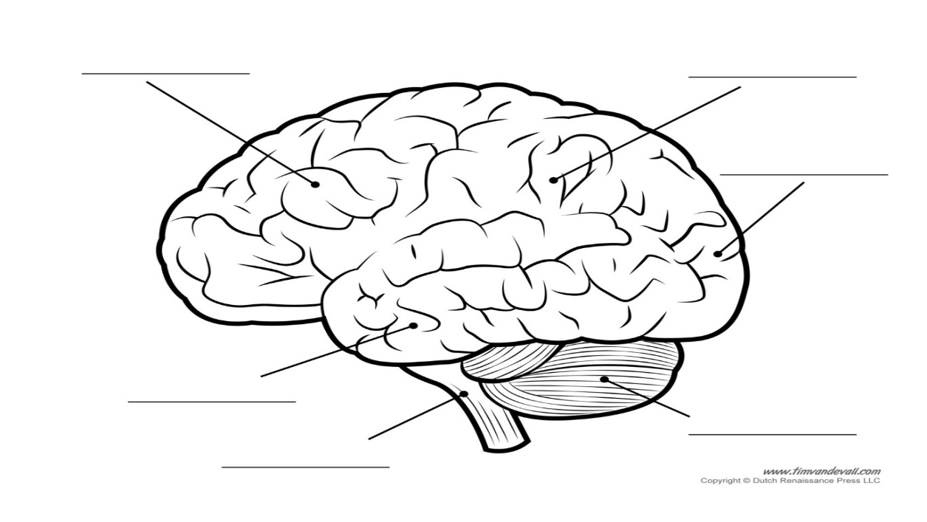

(c) Label the following diagram: (7 marks)

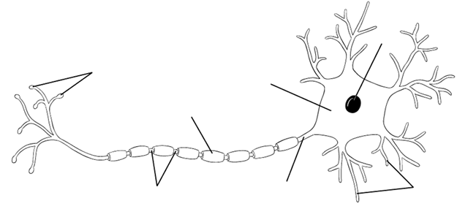

**Question 4 8 marks** a) Define the term *intelligence*. (1 mark)

|  |
| --- |
| An ability that enables us to learn, adapt to things around us, perform actions well, solve problems and think abstractly (Fletcher and Garton 2015) |

b) Discuss the differences between general and specific intelligence. (2 marks)

* General intelligence is an ability that showed itself in different ways depending on the environment/aids in a variety of tasks(1)
* Specific intelligence is an ability that allows you to perform well on one task and not on others (1)

c) Identify the following theories/theorists, from the descriptors below:

1. The theorist responsible for emotional intelligence. (1 mark)

Goleman

1. The theorist who introduced the idea of IQ. (1 mark)

Binet

1. A measure of a person's psychological abilities in comparison to the number of years it takes for an average child to reach the same level. (1 mark)

Mental age

1. What is meant by “cultural bias” in intelligence testing and how is this reduced in modern intelligence testing? (2 marks)

When a test is biased against or in favour of one particular culture. Cultural fair testing is done using symbols/patterns- no words

**Question 5 16 marks**

1. Define “trait” and list the number of possible traits Allport came up with:

(2 marks)

* TRAIT: a lasting disposition to act in a certain way in a variety of situations
* Traits: Observed emotional, cognitive or behavioural tendencies.
* 4500

1. List and describe Stages 2 and 4 of Maslow’s hierarchy of needs and name the goal of all people according to Maslow: (5 marks)

Stage 2: **Safety needs** - protection from elements, security, order, law, stability, freedom from fear.

Stage 4: **Esteem needs** - which Maslow classified into two categories: (i) esteem for oneself (dignity, achievement, mastery, independence) and (ii) the desire for reputation or respect from others (e.g., status, prestige).

Maslow indicated that the need for respect or reputation is most important for children and adolescents and precedes real self-esteem or dignity.

1. Explain the main criticism of Maslow’s theory: (1 mark)

Not based on empirical evidence

1. Name and describe the 3 constructs of Freud’s Psychodynamic theory and how they interact with each other to form one’s personality using a **specific** example:

(4 marks)

ID: Pleasure principle, primitive/biological drive to seek pleasure above all else. Totally Unconscious

Ego: Reality principle. Mostly conscious, balancer of id and superego

Superego: moral centre, taught by society, controls id, both conscious and unconscious

Interaction: Id is drive to pleasure, superego is drive to do what is moral, ego is balancer of the 2 based in reality

1. Explain Allport’s idea of “Cardinal” traits and “Central” traits using an example for each:

(4 marks)

**Cardinal trait:** An overriding trait that defines everything or almost everything a person does. Eg Someone who is always honest.

**Central trait:** A general tendency to think and behave in a certain way. Eg optimism, selfish. Allport believed that most people had between 5-10 traits.

**Question 6 Total 12 marks**

a) Before drifting off to sleep Melinda sat up and started to write and analyse a list of all the things she needed to do the next day.

1. Identify the hemisphere of the brain she would be using to compose her list.

Left (1 mark)

1. If Melinda is left handed which hemisphere of the brain would help her to move her hand to write the list? (1 mark)

Right

1. Identify the part of the brain that controls heart rate, breathing rate, reflexes and sleep.

(1 mark)

Hindbrain (brainstem) (1)- controls heart rate, breathing rate, reflexes, activities that are not under conscious control (1)

b) While Melinda sleeps she always has the air conditioner on. In the middle of the night, the air conditioner makes a strange noise which wakes her up.

**List and explain** the types of attention Melinda is exhibiting. (4 marks)

|  |
| --- |
| Habituation |
| The constantly repeated and unimportant stimulus of the air conditioner sound gets ignored after time. |
| Dishabituation |
| The sudden change in noise makes Melinda attend to the sound of the air-conditioner that she was previously not attending to. |

c) Once she wakes up Melinda checks her emails while watching the news.

Identify the type of attention Melinda is exhibiting. (1 mark)

|  |
| --- |
| Divided Attention |
| Melinda is undertaking two different activities at the same time (checking emails and watching the news) |

d) Sleeping is known to be an altered state of consciousness, however, having your eyes closed doesn’t necessarily mean you are asleep. Identify and explain **two (2)** physiological response measures that a doctor could use to show what state of consciousness Melinda was in. (4 marks)

Galvanic Skin Response: measures the conductivity of the skin, Perspiration increases the conductivity of the skin, perspiration increases through anxiety (2)

Heart Rate: an increased heart rate indicates a waking or alert state of consciousness (2)

Body Temperature: a higher body temperature indicates waking consciousness, fever and alcohol can also affect body temperature and indicate an altered state of consciousness. (2)

Brain waves (electrical activity of the brain); the higher the frequency the more alert the person is (waking consciousness) (2)

**Question 7 9 marks**

a) Describe the difference between sensation and perception. (2 marks)

Sensation involves our sense organs and the stimuli is sent to the brain for processing (1). Perception organizes and gives meaning to the stimuli (1).

b) Fill in the table below: (4 marks)

|  |  |
| --- | --- |
| **Sensory Organ** | **Stimulus** |
| **Nose** | **Chemical** |
| **Skin** | **Pressure** |
| **Tongue** | **Chemical** |
| **Eyes** | **Light** |

1. Explain how visual illusions work and give a specific example by naming and drawing one. (3 marks)

|  |
| --- |
| * Because we use “mental shortcuts” called “Heuristics”(1). Our brain tries to speed up processing (1) using experience and expectation. (1) |
| * Mueller-Lyer Illusion (1)   (1)  **or** |
| * Poggendorf Illusion (1) (1) |

**End of Section Two**

Section Three: Extended Answer 20% (26 Marks)

This section contains one (1) question.

Pages are included at the end of the two questions for planning and writing your answers.

* Planning: If you use a page for planning, indicate this clearly at the top of the page.
* You should refer to relevant psychological concepts, theories and research in your answer.

Suggested working time: 30 minutes

___________________________________________________________________________

Question 8 26 marks

Drugs and physical activity have been found to alter a person’s brain function and mental well-being.

Discuss how physical activity and drugs can alter a person’s brain function and mental well-being. Identify and discuss **two (2)** methods for investigating brain function.

In your answer, you should:

* Define relevant terms.
* Refer to relevant **theorists** related to physical activity that support the above statement.
* Discuss how drugs can alter a person’s brain function and well-being.
* Identify and discuss **two (2)** methods for investigating brain function.

|  |  |
| --- | --- |
| **Definitions** | **3** |
| Correct definitions (physical activity and emotional intelligence), with psychological theory discussed in relation to the topic | 3 |
| Correct definitions, but with some inaccuracy. | 2 |
| Generalisations, definitions using anecdotal evidence. | 1 |
| No definitions. | 0 |
| **Use of psychological evidence- Physical Activity** | **5** |
| Detailed description of one or more examples of relevant psychological research (summary of key research findings as well as details of study and researcher | 4-5 |
| Refers to one or more examples of psychological research but without detail (name of researcher and/or basic description of the study only | 2-3 |
| One or more personal or real life examples provided as evidence | 1 |
| No psychological evidence or incorrect evidence | 0 |
| **Drugs** | **9** |
| Drug types identified (depressant, stimulant, hallucinogen) 1 mark each  2 marks for detailed explanation of how each drug would affect a person’s brain function and wellbeing |  |
| **Brain Methods** | **6** |
| Any 2 of the following (one mark for identifying the method and two marks for explaining it)  EEG- measures brain activity by using electrodes to show brain waves. These can detect brain abnormalities such as epilepsy and brain tumors,  MRI- using magnets and radio waves to produce a 2D image that can be formed into a 3D picture that can be rotated to look for abnormalities of the brain tissue,  fMRI-detects brain function by measuring the amount of oxygen in the neurons of the brain, more oxygen shows more activity of the brain,  PET-the patient takes a glucose tracer that goes to the brain to show where glucose consumption is in the brain, the more glucose consumption the more brain activity,  CAT-using x-ray imaging it takes cross-sectional sliced pictures of the brain that can help detect for abnormalities, strokes, and other injuries that may have caused changes in behaviour, |  |
| **Structure** | **3** |
| A well-constructed answer, use of appropriate psychological language | 3 |
| Answers with well-developed sentences and paragraphs | 2 |
| Lack of paragraph structure and incoherent responses | 1 |
| Answer is too brief or irrelevant | 0 |
| **TOTAL** | **/26** |

Refer to relevant theorists related to physical activity

* McCann and Holmes, Fields, Myers